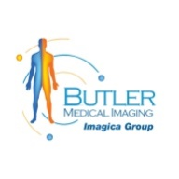Benefits of OPG Dental X-Rays for Dental Care at Butler Medical Imaging. (08) 9544 3999

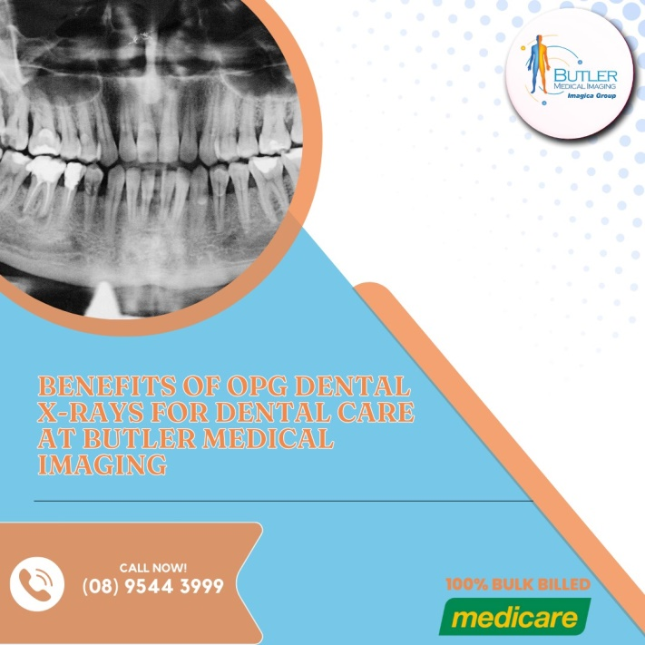At Butler Medical Imaging, we are proud to offer OPG dental X-rays, which provide a panoramic view of the entire mouth, offering crucial insights into a patient's oral health. This article explores the many benefits of OPG dental X-rays and how they enhance the quality of dental care.

**What is an OPG Dental X-ray?**

An Orthopantomogram (OPG) is a specialized type of [dental X-ray](https://butlerimaging.com.au/dental-xray-opg/) that captures a wide, panoramic image of the mouth. Unlike traditional intraoral X-rays, which focus on individual teeth or small areas of the mouth, OPG X-rays provide a comprehensive overview of the teeth, jaws, and surrounding structures, all in a single image. This panoramic perspective is essential for detecting various dental and orthodontic issues early on and plays a significant role in treatment planning.

**1. Comprehensive Overview of Dental Structures**

One of the main benefits of OPG dental X-rays at Butler Medical Imaging is the ability to capture a wide, detailed view of the entire oral cavity. This single image includes the teeth, jaws, temporomandibular joints (TMJ), and surrounding bone structures. This comprehensive view allows dentists to assess the overall health of the mouth without needing multiple, [localized X-rays](https://butlerimaging.com.au/dental-xray-opg/).

**2. Enhanced Diagnostic Capabilities**

OPG dental X-rays offer superior diagnostic capabilities, allowing dentists to detect oral health problems early on. Many dental issues, such as cysts, tumors, and infections, may not be visible during a routine clinical examination. Dental X-ray (OPG) provide a clear image of the bone structures beneath the gums, making it easier to identify hidden conditions.

At Butler Medical Imaging, our state-of-the-art OPG technology enables early detection of oral health issues, allowing for prompt intervention before these problems escalate into more serious conditions. Early diagnosis is crucial for [preventing](https://butlerimaging.com.au/dental-xray-opg/) complications, reducing the need for invasive procedures, and improving long-term outcomes for patients.

**3. Improved Treatment Planning**

OPG dental X-rays are essential for formulating accurate and effective treatment plans. Whether a patient requires orthodontic treatment, dental implants, or extractions, an OPG X-ray offers the detailed information needed for precise planning. The wide panoramic image helps dentists evaluate:

* The position of the teeth and their roots
* The relationship between the upper and lower jaws
* The condition of the jawbone and surrounding tissues

**4. Non-Invasive and Comfortable for Patients**

One of the key advantages of OPG dental X-rays is their [non-invasive](https://butlerimaging.com.au/dental-xray-opg/) nature. Traditional intraoral X-rays require the patient to hold sensors or film inside the mouth, which can be uncomfortable and may trigger a gag reflex. This is particularly challenging for young children, elderly patients, or those with special needs.

In contrast, OPG X-rays are taken externally, with the patient standing or sitting in front of the machine while the scanner rotates around the head. This process is quick, painless, and significantly more comfortable for patients. At Butler Medical Imaging, we prioritize patient comfort and ensure that our OPG X-ray procedures are as smooth and stress-free as possible.

**5. Reduced Radiation Exposure**

Another benefit of OPG dental X-rays is the lower radiation exposure compared to traditional intraoral X-rays. Since Dental X-ray (OPG) provide a single [panoramic](https://butlerimaging.com.au/dental-xray-opg/) image, they require fewer X-ray exposures, thereby minimizing the overall radiation dose. This is especially important for patients who may need repeated imaging, such as those undergoing orthodontic treatment or long-term dental care.

At Butler Medical Imaging, we use advanced OPG equipment designed to minimize radiation exposure while still delivering high-quality, detailed images. This ensures that patients receive the safest and most effective diagnostic care possible.

**6. Facilitates Collaboration with Other Specialists**

OPG dental X-rays are also valuable in fostering collaboration between dental professionals. The panoramic images can be easily shared with other specialists, such as oral surgeons, orthodontists, or periodontists, for a more comprehensive approach to patient care. For example, when planning complex procedures like jaw surgery or orthodontic corrections, an [OPG scan](https://butlerimaging.com.au/dental-xray-opg/) provides the necessary information for all specialists involved in the treatment plan.

At Butler Medical Imaging, we work closely with referring dentists and specialists to ensure that our Dental X-ray (OPG) contribute to a seamless and coordinated approach to dental care. This interdisciplinary collaboration enhances treatment outcomes and provides patients with the highest standard of care.

**7. Ideal for Monitoring Oral Health Over Time**

For patients undergoing long-term dental or orthodontic treatment, OPG dental X-rays are an ideal tool for monitoring progress over time. Routine [Dental](https://butlerimaging.com.au/dental-xray-opg/) X-ray (OPG) allow dentists to track changes in the teeth, jaws, and surrounding structures, ensuring that treatment plans remain effective and up-to-date. Regular imaging also helps detect any new issues that may arise, allowing for timely adjustments to the treatment plan.

At Butler Medical Imaging, we offer Dental X-ray (OPG) as part of routine dental check-ups to help patients maintain optimal oral health. By monitoring changes in the mouth over time, we can help prevent serious dental issues and ensure that patients receive the best possible care.

**Why Choose Butler Medical Imaging?**

We are local and a privately-owned medical clinics that offers the highest quality medical and Imaging Services in the [Butler Medical Imaging](https://butlerimaging.com.au/appointment/) region. We are the leaders in Bulk Billing with the real benefit of no ‘Out of Pocket’ expenses for you.

**Your Next Step**

Please ensure that you have your Medicare card and referral with you and pop into our location for your consultation. If you have any questions at all, please feel free to contact us at [+61 8 9544 3999](https://butlerimaging.com.au/appointment/) as we are here to help.